Story

Date | 27 October 2026
Team ID | Not provided by user
Project Name | Global Olympic Sports Performance Analysis
Maximum Marks | 5 Marks

By using stories in Tableau, you can effectively communicate complex data in a way that is both interactive and engaging, making it easier for the audience to follow along and understand the insights. It’s a tool for data storytelling, allowing you to present insights in a cohesive, engaging way that takes viewers through a logical progression of findings or analyses.
In Tableau, Story is a feature that allows you to create a sequence of dashboards, visualizations, and text to present data insights in a cohesive and narrative-driven way. It's like a slideshow within Tableau that guides the audience through a series of data points, helping them understand key insights, trends, or outcomes of your analysis.

Olympic Storyboard - Narrative Sequence

Story Point 1 - Compare Country Performance
Start with “Global Performance by Country” to identify how the workbook ranks countries by total medals. Use the Overall Rank field/filter to focus the comparison and confirm the sort order. Avoid reporting unverified numeric totals.

Story Point 2 - Track the Medal Trend
Move to “Trend of Total Medals Awarded” and inspect the year-by-year pattern. Highlight broad increases/decreases and explicitly note that the number of events and data coverage can change over time.

Story Point 3 - Compare Categories and Regions
Use average medals by sport category, average medal efficiency by region and regional medal distribution to investigate differences. Explain how each measure is defined and avoid equating an average with a causal explanation.

Story Point 4 - Add Context: Investment and Host Status
Review the investment-versus-medal scatter plot and host-nation comparison. Describe observed association only; a rigorous host or investment effect requires time-series comparisons and controls for other influences.
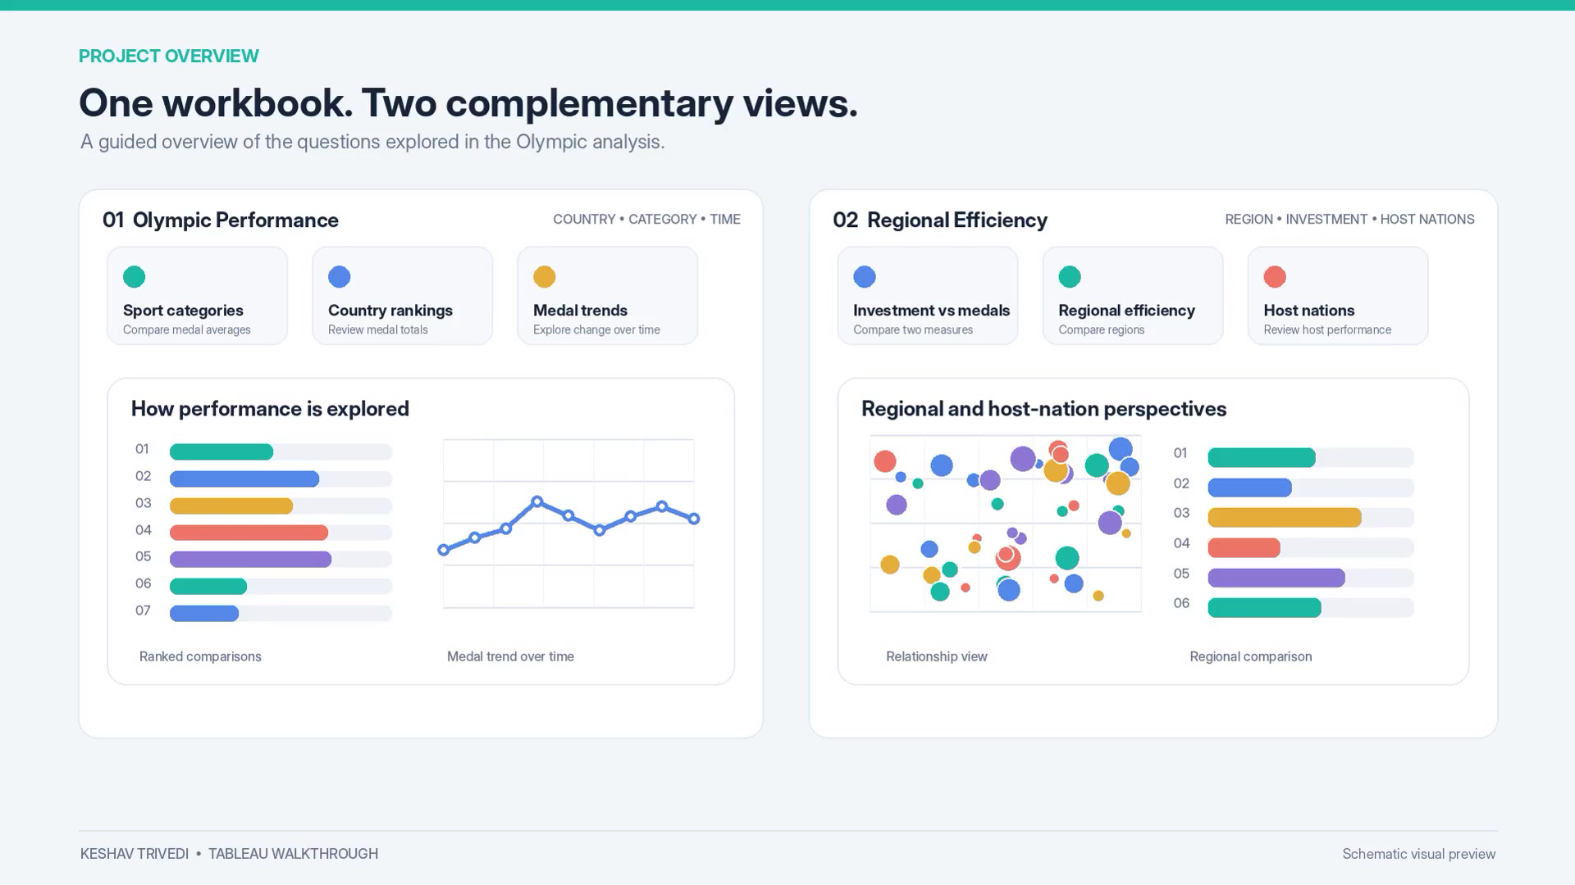
Figure 1. Overall project narrative overview from the supplied walkthrough video.

Tableau Story / Public Link Status
The supplied .twbx currently has two dashboards and no Tableau Story object in its workbook XML. This document is a completed story design, but the story points still need to be created inside Tableau and the workbook repackaged. Tableau Public link: not published / not supplied.

